http://www.notebook.hu/lenovo-ideapad-y700-80nv00f1hv

LENOVO IdeaPad Y700 (80NV00F1HV) (319 900 Ft)

15.6" FULL HD-LED GlareType 1920x1080 pixel
Intel® Core™ i7-6700HQ Processor (6M Cache, up to 3.50 GHz)
4GB DDR4
1TB 5400RPM SATA
NVIDIA® GeForce® GTX 960M 4GB
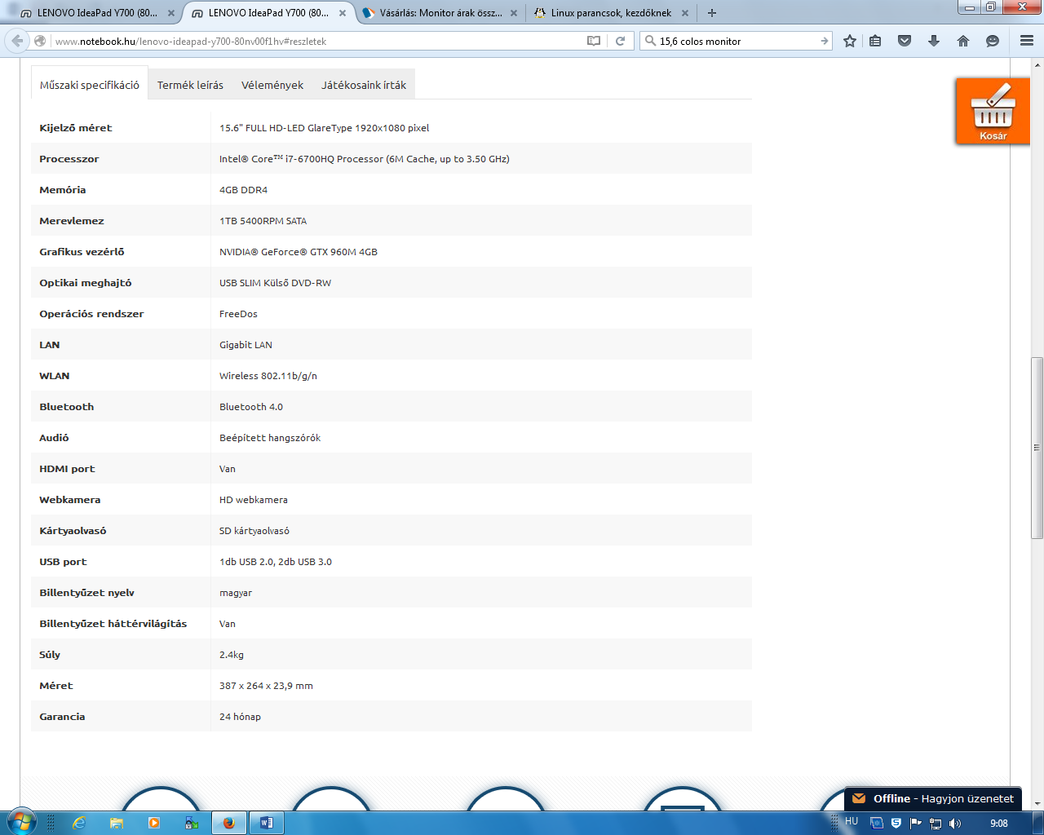

PC

http://www.edigital.hu/Monitor/Samsung-S22D300HY-215-LED-Monitor-p411494.html?bid=&partner=11016

Samsung S22D300HY 21,5" LED Monitor (36990 ft)
http://microstore.hu/index.php?route=product/product&product_id=201877

Intel Core i7-6700 3.4GHz BOX Skylake (BX80662I76700) (100886 Ft)
http://www.bluechip.hu/termek/kingston-ddr4-2133mhz-4gb-cl15
Kingston DDR4 2133MHz 4GB CL15 (7520 Ft)
http://www.mercateo.hu/p/1505-HTS541010A9E680/HDD_Mobile_HGST_Travelstar_5K100_2_5_1TB_8MB_SATA_III_600_SKU_0J22413.html?showSimplePage=NO&

HDD Mobile HGST Travelstar 5K100 (2.5'', 1TB, 8MB, SATA III-600)., SKU: 0J22413 (14832 Ft)
https://www.pcland.hu/gigabyte_pcie_n960wf2oc-4gd_4gb_gddr5_128_-gv-n960wf2oc-4gd?forras=3
VGA kártya - Gigabyte PCIe N960WF2OC-4GD 4GB GDDR5 128 Bit HDMI 2xDVI 3xDP (67 818 Ft)
Összesen: 228046 Ft

